INTERNAL COMPONENTS & WORKING FLOW
INTRODUCTION:
- A digital timer is an electronic device that uses microcontrollers and digital displays (LED/LCD) for highly accurate timekeeping, offering features like countdowns, repetitive cycles, and easy programming via buttons or touch panels, making them essential for automating tasks in homes, industries, and appliances by controlling power to devices, saving energy, and ensuring precise operation.
Internal components:
- Microcontroller
- Power Supply Unit
- Display
- Control Interface (Input)
- Output Mechanism
- Oscillator / Clock Source
- Memory (EEPROM/Flash)
Working of components:
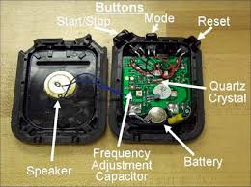
- Microcontroller / Integrated Circuit (IC): This is the brain of the timer, responsible for the actual timing function and logic. It uses internal circuitry (like a time-base unit and control logic) to keep time accurately. For simple timers, a 555 timer IC might be used, which contains internal resistors, comparators, a flip-flop, and a discharge transistor.
- Power Supply Unit: This section regulates the incoming voltage to power the internal electronic components. Many digital timers also include a backup battery to retain memory and settings in case of a main power failure.
- Display: A visual interface, typically an LCD (liquid crystal display) or LED (light-emitting diode) screen, to show the current time, remaining time, or programmed settings.
- Control Interface (Input): This includes physical buttons, a keypad, or a touch panel that allows the user to program the timer, set modes, and perform manual overrides or resets.
- Output Mechanism: When the set time is reached, the timer needs to signal or control an external device. This is often achieved through a relay module or solid-state switch, which can turn connected machines or lights on or off.
- Oscillator / Clock Source: An internal oscillator, often a crystal, provides a stable, regular frequency signal that the microcontroller uses to count time precisely.
- Memory (EEPROM/Flash): Industrial-grade and programmable timers typically have non-volatile memory to store the user's settings and programs even if the power is completely lost and the backup battery runs out.
These components work together to provide precise, programmable time control for various applications.
Workflow:
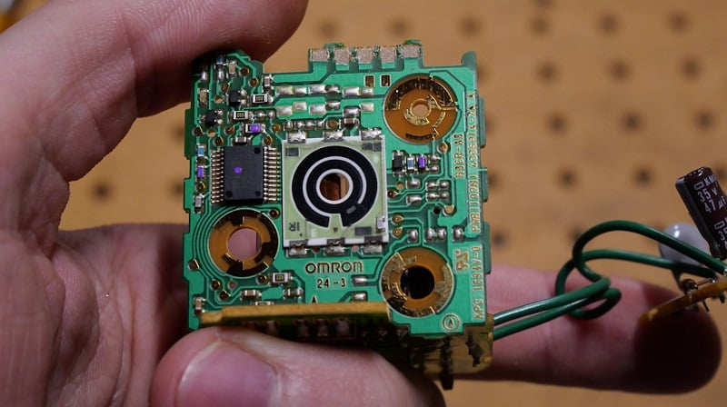
- Input/Configuration: A user programs the desired time interval and mode of operation (e.g., a 10-minute "on-delay") using the control buttons. The microcontroller stores these settings in its memory.
- Triggering: An event, such as applying power or receiving a start signal, initiates the timing process.
- Timing/Counting: The microcontroller starts counting based on the internal clock source. It continuously compares the elapsed time with the preset duration.
- Monitoring: The current time is displayed on the screen, providing instant visual feedback to the operator.
- Output Activation: When the internal count matches the preset time, the microcontroller sends a signal to the output mechanism (relay), changing its state (e.g., from OFF to ON) to control an external device.
- Termination/Cycle: Depending on the mode, the process might stop, reset, or repeat the cycle. In a workflow management system, once the timer duration is completed, it can send an event back to the main workflow to continue the next activity
Circuit:
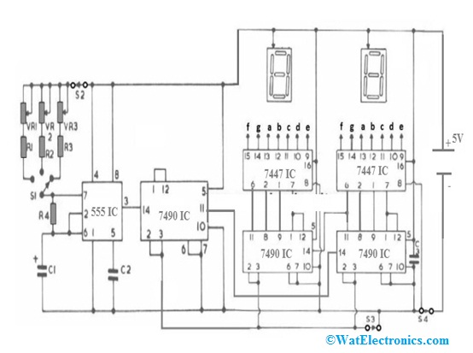
Circuit explaination:
- A digital timer circuit works by using an accurate clock source (like mains frequency or crystal oscillator) and counters (flip-flops, BCD counters) to divide time into precise intervals, controlled by a microcontroller or logic ICs, then displaying it on LEDs/LCDs and triggering outputs (relays) after a set duration, functioning through sequential logic to count down from a preset time or trigger events.
Application:
- Countdown/Count-Up: Set specific durations or measure elapsed time.
- Stopwatch: Precise time measurement with lap/split functions.
- Interval Timers: Set work/rest periods for workouts (HIIT,tabata) or focus session.
- Multiple Timers: Run several timers simultaneously for different tasks.
- Customization: Unique sounds, text-to-speech, color changes, full-screen modes.
- Widgets: Quick access and visibility from your home screen.

